May & June Newsletter: End of the School Year

St. John’s Lutheran School

**N E W S L E T T E R**

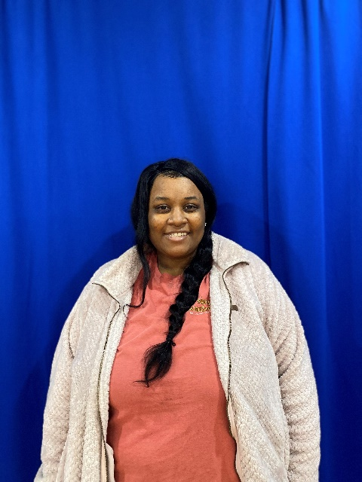

**5th -** Madelyn Orsborn

**5th -** Addisyn Thomas

**5th -** Sunhi Jin

**5th -** Gabriel Stark

**5th -** Elora Pruitt

**5th-** Jacob Marchand

**3rd -** Isaac Triplett

**3rd -** Jayden Hay

**3rd -** Grant Pizzitola

**3rd -** Uma Tulchinsky

**3rd -** Elijah Norris

**The Spelling Bee Winner Is…**

**GABE STARK**

We will continue collecting ‘baby bottles’ filled with spare change, for The Salem Pregnancy Center Baby Bottle Campaign until Wednesday, May 25Th. These donations will go to expecting mothers who need help! The ‘baby bottles’ can be picked up and returned to the front office! There is a ‘baby bottle’ in each classroom, whichever raises the most money will earn a donut party for their whole class!

Welcome to

St. John’s

Renee Collins will be aiding in the Preschool room!

**Please turn in lunch menus before**

**May 18th.**

St. John’s invites & welcomes anybody looking for **Christ** to join us for Sunday Service!

**Contemporary Worship**- 8:30AM

**Bible Study**- 9:30AM

**Traditional Worship**-10:30AM

**Spelling Bee; Show Down**

St. John’s Annual K-5 School Spelling Bee was held on April 21st, in the Church. Grades 2nd-5th participated in the Spelling Bee! These children went up in front of all their peers to test their spelling ability. These kids did a wonderful job & we are proud of each of them!

**Spelling Bee Participates…**

**2nd -** Jonah Hargis

**2nd -** Canaan Brown

**2nd -** Nicholas Greenway

**2nd -** Khieryn Binkley

**4th -** Mitchell Keller

**4th -** NaSia Lovelace

**4th -** Samantha Falsis

**4th -** Philip Reed

**Your Change; Saves Lives**

**Look Forward to…**

**THANK YOU…**

We just want to thank everyone who has helped throughout the year, from Book Fair, Class Parties, and Special Events! We appreciate everything! If you see them around give them a special thank you!

Jill Careccia, Nicole Shannon, Steve & Dot Anderson, Norman & Sam Drouillard, Rachel Orsborn, Florence Mathon, Rachel Haynes, Courtney Pizzitola, Jenny Espinoza, Stephanie Polnak, Nicole Shannon, Kelly Faulkner, Renee Brown, Jennifer Metz, Leanna Brendle, Courtney Reed, Leigh Wisner, Margaret Pruitt, Kris Gartley, Cheryl Wulfurt, and many more…

**- May 6th -**

*Kindergarten Field Trip*

**- May 11th (Chapel) 8:45 AM -**

**- May 12th (Evening) 7:00 PM -**

*K-2 Grade Spring Programs*

(In cafeteria)

**- May 13th -**

*2nd Grade Field Trip*

**- May 18th (Chapel) 8:30 AM -**

**- May 19th (Evening) 7:00 PM -**

*3-5 Grade Spring Programs*

(In cafeteria)

**- May 20th -**

*5th Grade Field Trip*

**- May 25th -**

*Baby Bottle Campaign Due*

**- May 30th -**

*Memorial Day*

* (NO SCHOOL) *

**- May 31st -**

*1st Grade Field Trip*

**- June 1st -**

*Field Day*

**- June 2nd -**

*4th Grade Field Trip*

**- June 2nd -**

*5th Grade Graduation*

(in Chapel at 7:00 PM)

**-June 3rd -**

*K-4th Grade Awards Day*

(8: 30 – 10:30 AM)

**- June 3rd -**

*LAST DAY OF SCHOOL*

(EARLY RELEASE at 12:00 PM)

**K-5 Curriculum Fee: $300**

**Preschool Curriculum Fee: $150**

**Curriculum Fees:**

Just a reminder that curriculum fees for K-5 2022-2023 school year are due July 1st. Curriculum fees for Preschool 2022-2023 school year are due on July 31st.

**CLASSROOM PARTIES:**

With the end of the year coming up, each classroom will do something special for their classrooms. Please keep a look out for the dates, and if any volunteers may be needed! We want to thank our teachers for what a great year we have had so far!

**LIBRARY BOOKS:**

Last day to check out books is Wednesday, May 18th. All books are due back on Wednesday, May 25th. Any lost or past due books are do the same day!

Two third grade girls have created a Book Club here at St. John’s. They will meet every Wednesday after school in Room #100. From 3:15 PM- 4:15PM. Sign-up forms can be found in the school office! Join for books, crafts and more!!

**BOOK CLUB:**

Although our time has almost finished,

Your smiles will never fade.

We will not forget the handprints left

On memories you have made.

**HAVE A GREAT SUMMER ST. JOHN’S FALCONS!**

**SEE YOU IN THE NEW SCHOOL YEAR!**

Two Fancy Rats:

Mushu & Cricket

Two Guinea Pigs:

Biscuits & Gravy

The last day of 2021-2022 school year will be Friday, June 3rd (Early Release). The first day of the new school year 2022-2023 will be Wednesday, August 17th (Early Release)

**SUMMER BREAK IS ALMOST HERE...**

**Welcoming Our New Fury Friends…**

Nathan Kottlowski

**The Last: From the Principal’s Desk**

in our important work.  The COVID pandemic was our most crucial issue for staff coverage and continuing our excellence in academics while showing all our children the love of Jesus, and for aiding us to see opportunities of service to each other and our community. I have been very blessed with my staff of teachers for working as a team in keeping the classrooms clean and doing the little things to ensure all the necessary jobs were done for our children to be safe and ready to start each day. I am thankful for our faithful custodian, Mr. Cat and his wife Luisa. They show tireless effort in cleaning up all the rooms at the end of the day and keeping our school sparkling. I am thankful for our lunch ladies, Holly Wilson and Lisa Little, and their efforts for preparing tasty meals for our children. I am thankful for the administrative staff of Tom Baldwin, Sonia Davidson, Heather Bullock, Autumn Beard, Kerstin Walker, and Pastor Tom. We all have our special talents and jobs to complete for keeping the school running efficiently. I could not guide this school without all these dedicated workers for the Lord Jesus. It has been my joy and honor to have been a part of this school ministry by helping our students learn.

The next newsletter will be from your new principal, Tiffany Banks. She will be taking over the role of principal on July 1. I will be around to assist her in the transition. I am sure we will have a fellowship event to meet and greet her sometime at the end of July or the first of August for everyone to come out and meet with her. Mrs. Banks comes to us from Amplus Academy Elementary School in Las Vegas, NV with excellent references and credentials as she leaves her assistant principal position there to join us here in June.  She is a fellow Lutheran and will be joining our church membership, as well.  I have met with her and have found her to be very organized and engaging with an encouraging spirit for helping children learn. I know you will like her. Her husband, Scott, and son, Jace, a rising 4th grader, are the other part of her family and moving here in June with her. Please keep Mrs. Banks and her family in your prayers as they prepare for this move across the country.

**-The School Minibus and Van are now up and running for our field trips in May. Thanks go out to Mr. Steve Anderson and Mr. Norman Douillard for getting that work done.**

**-Community service and outreach – Our Baby Bottle campaign for the Pregnancy Center will continue through May 27th.**

**-Mrs. Patterson and Mr. Baldwin will again be doing the May Baskets with the 4th & 5th graders, and they are distributed around our community neighborhood.**

**-End of School week actives – Field Day, 5th Grade celebration/graduation, Awards Day and the Last Day of School, Friday, June 3rd at 12:00 Noon.**

So, this newsletter is bittersweet for me, as I am approaching the end of my school time here as your principal and write my final newsletter greeting to you. We are completing our school year in May and June and as I reflect on these past two years, I am thankful for all that the Lord has done to help us find our way through many challenges. There have been some incredible blessings He has provided us in bringing new families, keeping us safe in our face-to-face instruction, and guiding my staff and me

CV

**Photos from Our Year 2021-2022**